CPE /EE 556 A: Assignment one

Matthew Marseglia 2/16/26

Instructions:
- upload one Microsoft text document that includes commented code for each part and YouTube links to the video demos.
- This assignment is out of 12 points
- Important Note: Please do not use any of the revised pins. Otherwise, your board will stop working.

Part 1: The Simple Blink
Q1. Modify the project GPIO_output_LED to make the LED blink slower.
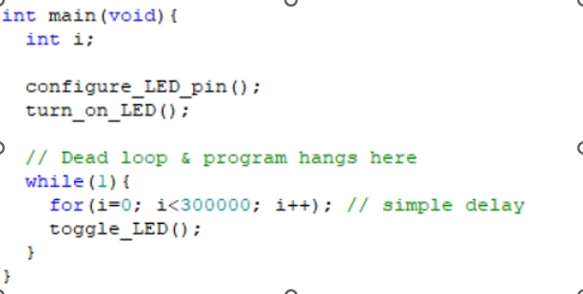
Changed count from 100000 to 300000
Video demonstration: https://youtube.com/shorts/VU7AZSfX5a0

Q2. Modify the project to blink an out-of-board LED.
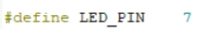

Modified pin to PA7
Video demonstration: https://youtube.com/shorts/s_yMyOKB0sI

Part 2: Button Blink
Q3. Modify the project such that it sets a Pin as an output and another Pin as an input. If the button is pressed the LED will begin to blink. When the button is released, the blinking will cease. Please use an out-of-board LED and switch and do not use the on-board button or LED. The following figure shows how to connect the switch, the capacitor is used to drain the switch bouncing noise.
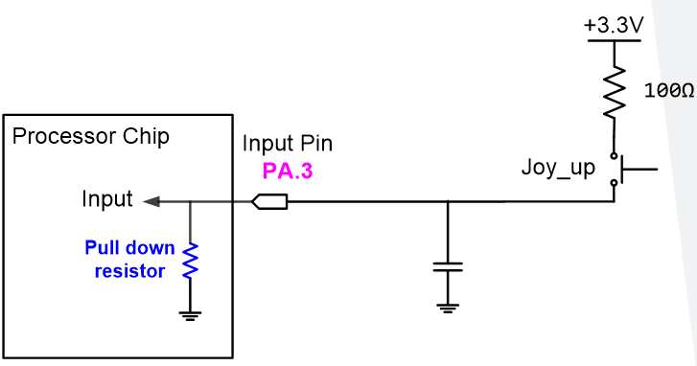
Push button
switch

1kΩ
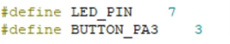
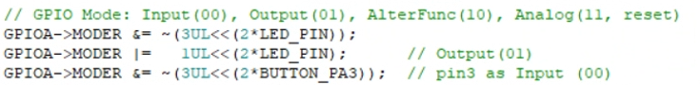
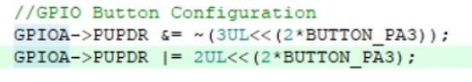
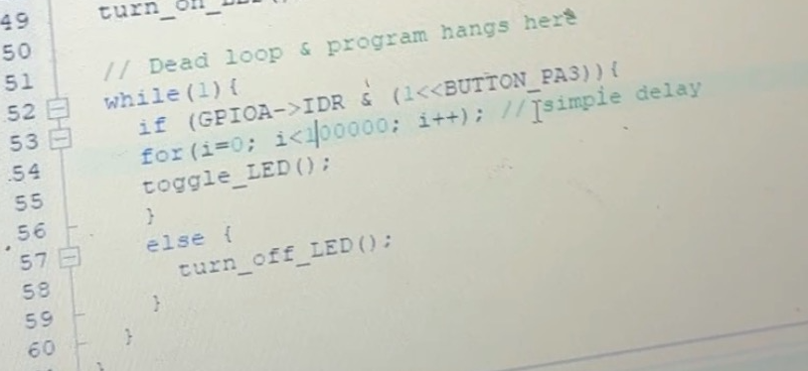
Defined new GPIO pin, designated MODER, PUPDR, etc and followed schematic.
Video demonstration: https://youtube.com/shorts/shcdim5fo3I?feature=share

Part 3: Multiple Blink
Q4: Now that we have blinked at least 1 LED, what about blinking multiple LEDs at the same time? The minimum that you need to develop is blinking at least three LEDs at different rates. Although I am not going to give you speed, you should probably pick a rate, which is visible to a standard human.

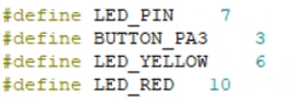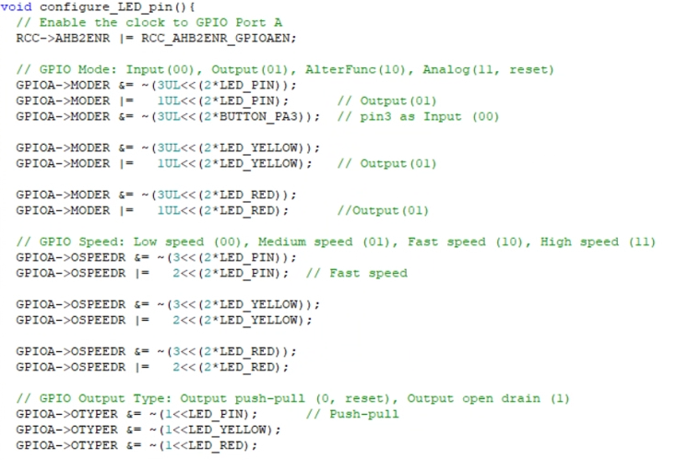
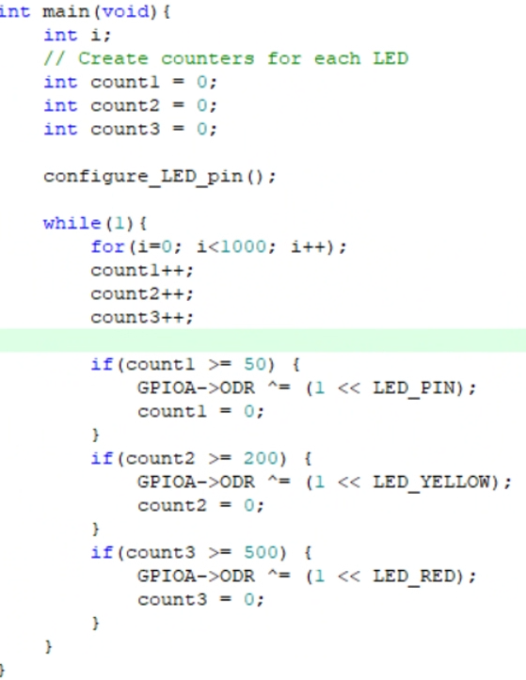
Added three counters in main function for each respective LED.
Designated two new GPIO output pins 10 and 6 with corresponding register information
Video demonstration: https://youtube.com/shorts/_jeVjuz-ONE

Part 4: troubleshooting
Q5: the project GPIO_output (always ON), attached with this assignment, is supposed to toggle the on-board LED connected to pin PA5 of the Nucleo-STM32L476 development board, but it does not work properly and the LED is always ON. Check the code and try to find the reason me the reason?

The reason for this would be that within the integer main function the code initially calls the turn_on_LED() function before entering the loop. Once inside it performs a delay and eventually calls the toggle_LED() function. Therefore by calling the led to turn on the led will always be on before any looping is started.

Part 5: generative AI
Q6: Explain how do generative AI tools like ChatGPT or Copilot have helped you with the assignment
Generative AI tools like ChatGPT and Copilot have assisted me with this assignment by pointing out errors in my code as well as offering suggestions on how to optimize the iterative process. Whenever I was stuck for more than 5 minutes, I would ask an AI tool to assist me in figuring out how to complete the question. I also fed it the lecture slides as a form of review for this assignment to better understand the course material.

Note: Please use the morpho headers, not the Arduino headers.

